Using Google Maps

How to Use Google Maps.
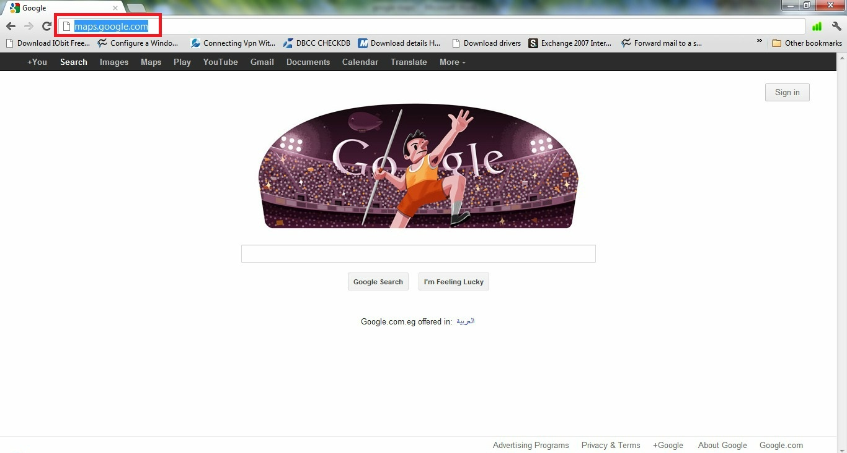
-Type << maps.google.com >> on the address bar of any internet browser.

- Type the place you want to find on the search box then press Enter.
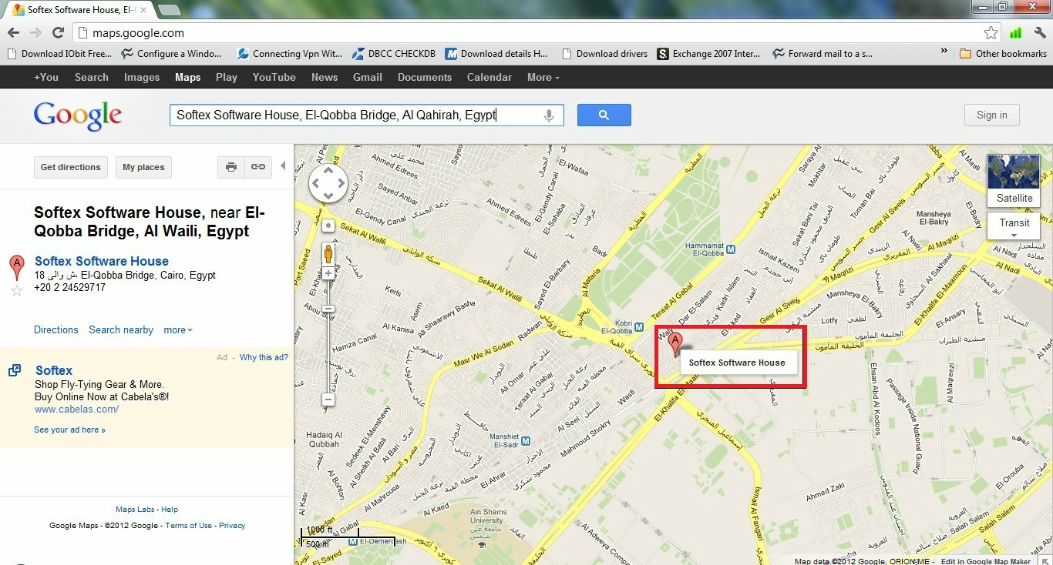

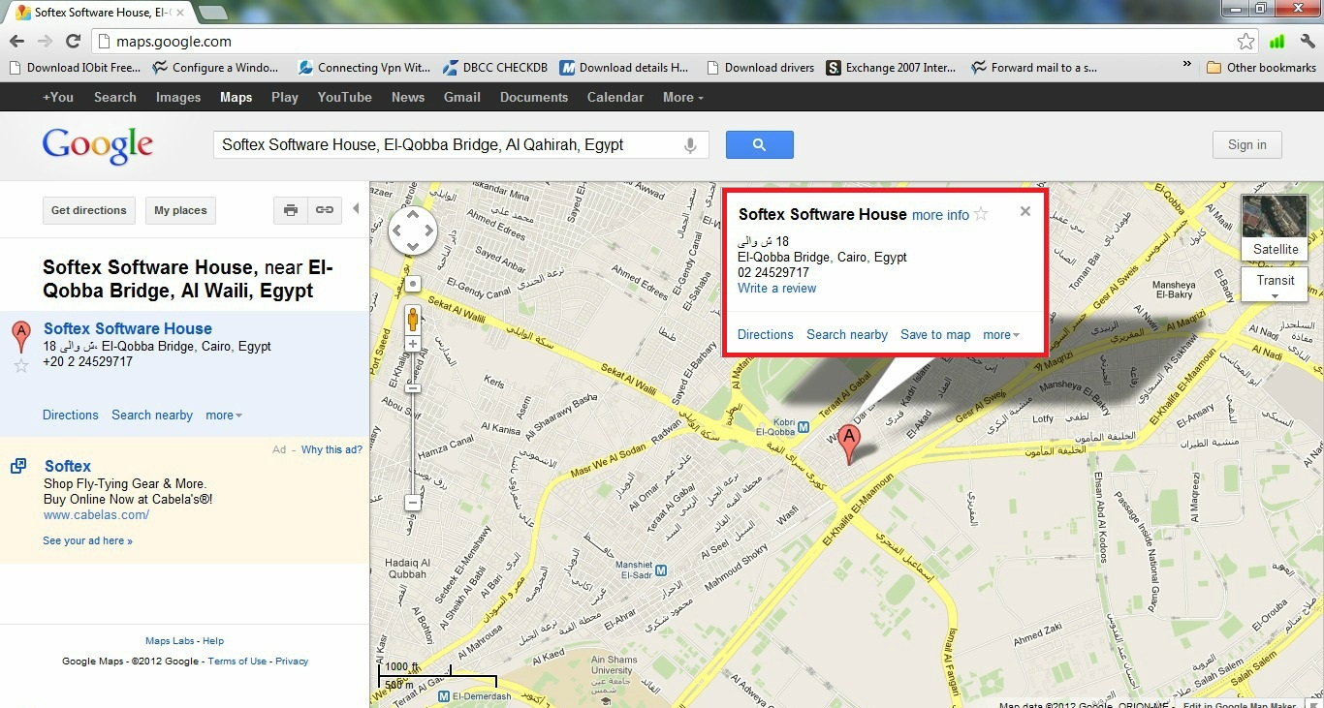
- you will find the location and the available information about the required place on the map.
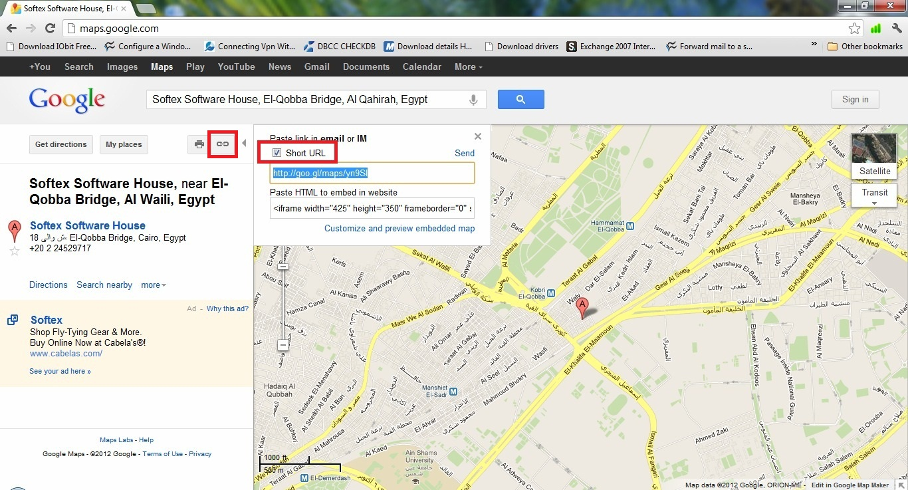
- you can get the link of the place on the map by clicking on the icon (link) , you also you can copy it and send it to any friend

